BlackJack: Develop and Deploy Guidelines

Table of Contents

BlackJack: Develop and Deploy Guidelines 1

Overview 3

Software Download List 4

Installing JDK 5

Windows 7 – Setting Environment Variables 6

Setting Up JAVA_HOME, PATH, and CLASSPATH Environment Variables 6

Windows 10 – Setting Environment Variables 7

Setting Up JAVA_HOME, PATH, and CLASSPATH Environment Variables 7

Verifying the JDK Installation 9

Installing Netbeans 10

Verifying the Netbeans Installation 10

Installing GIT 11

Verifying the GIT Installation 12

Installing Maven 13

Windows 7 – Setting Environment Variables 14

Setting Up the M2_HOME, M2, and PATH Environment Variables 14

Windows 10 – Setting Environment Variables 15

Setting Up the M2_HOME, M2, and PATH Environment Variables 15

Verifying the Maven Installation 17

Creating a GIT Repository 18

Configuring a GIT Repository 18

Proxy Settings for Maven 19

Creating a Project with Maven Archetypes 20

Checking the Helloworld-Example Project into a GIT Repository 29

Creating a Developer Cloud Service Project 31

Activating Developer Cloud Service 31

Creating a GIT Repository in Developer Cloud Service 38

Cloning a GIT Repository 40

Downloading BlackJack Project from the Repository 42

Deploying the BlackJack Application on a Local Server 43

Testing the Locally Deployed BlackJack Application 47

Generating Application Archive Files for the BlackJack Application 49

Activating Oracle Application Container Cloud Service (OACCS) 51

Deploying the BlackJack Application on OACCS 53

Testing the BlackJack Application Deployed on OACCS 58

Overview

This document helps students understand the process to setup the Java development environment on their computer, create project using “Maven” and “Netbeans” and deploy it on Developer Cloud Service.

Here students deploy their existing “Blackjack” project on a local Application Server, followed by deploying it on Oracle Application Cloud Container Service and finally accessing it from an HTML-5 client.

**Important Note:** Login credentials like Identity Domain Name, User Name and Password are required to work with Developer Cloud Service and Oracle Application Container Cloud Service. Gather this information from the email you have received from Oracle and keep it handy

Software Download List

|  |  |
| --- | --- |
| **Name and Version** | **Download Link** |
| **JDK 8 or higher** | <http://www.oracle.com/technetwork/java/javase/overview/index.html> |
| **Netbeans 8.1 or higher** | <https://netbeans.org/downloads/> |
| **GIT 2.11.0.3 or higher** | <https://git-scm.com/downloads> |
| **Maven 3.3.9 or higher** | <http://maven.apache.org/download.cgi> |

**Note: List of software mentioned in the above table can be downloaded and stored onto your computer before you get started to save download time.**

**Or**

**Software can be downloaded as you go along with the exercises. Each exercise contains detailed steps for downloading and installing required software.**

**It is assumed that you will be working on a 64bit setup and provided instructions accordingly to download and install software. If you are not working on 64bit setup then download the software compatible to with your setup.**

Installing JDK

Use the following instructions to download, install, and configure Java Development Kit on your computer.

**Note: JDK-8U121** is the latest version of JDK available at the time of creating this document. It is highly recommended that you download the newer version of JDK (if available) and perform these lab activities.

If you already have the JDK 8 or higher version installed on your computer then skip **Installing JDK** step and proceed with **Setting Up JAVA_HOME, PATH, and CLASSPATH Environment Variables** to setup/verify environment variables.

1. In the Firefox browser, navigate to <http://www.oracle.com/technetwork/java/javase/overview/index.html>
2. Click the **Downloads** tab and download the latest version of JDK available. In this case, we are downloading JDK-8U121.

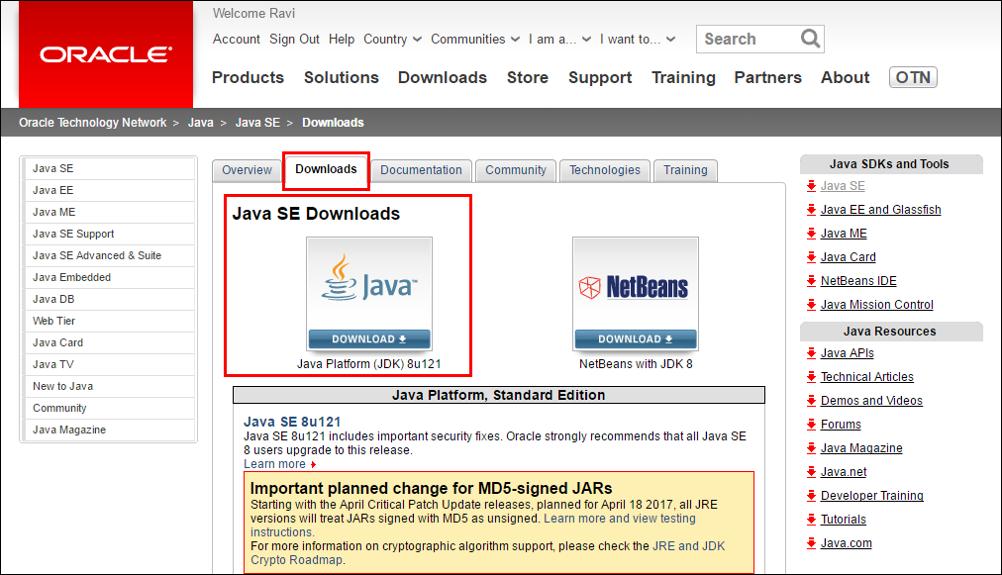

1. You must accept the “Oracle Binary Code License Agreement for Java SE” to download the software. Click the **Accept License Agreement** button.
2. Download the **jdk-8u121-windows-x64.exe** installer file on to your computer. The download may take some time. Wait for the download to complete before proceeding to the next step.
3. Double-click the **jdk-8u121-windows-x64.exe** file to start the installation.

**Note:** If you receive a security warning such as “Do you want to allow the following program to make changes to this computer?” click **Yes**.

1. When the installer opens, click the **Next** button.
2. Accept the default installation locations and click **Next** twice.
3. Wait until the installer installs the JDK successfully and displays a “Java SE Development Kit 8 Update 121 (64-bit)” message. Click the **Close** button.

Windows 7 – Setting Environment Variables

Setting Up JAVA_HOME, PATH, and CLASSPATH Environment Variables

**Note:** You must be logged on to your computer as the Admin user.

1. Click the Windows **Start** button. Right-click **Computer** and select **Properties**. Click **Advanced system settings**.
2. Click **Environment Variables**.
3. In the Environment Variables window, under **System Variables**, click the **New** button.
4. In the New System Variable window, enter the Variable name **JAVA_HOME**, enter the Variable value **C:\Program Files\Java\jdk1.8.0_121,**  and then click the **OK** button.

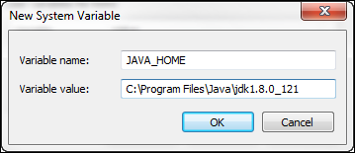

1. Select **PATH** system variable and click the **Edit** button (If PATH system variable is not available, click the **New** button to create PATH variable, enter the Variable value **C:\Program Files\Java\jdk1.8.0_121,** and then click the **OK** button).
2. In the Edit System Variable window, in the Variable value field, place the cursor at the starting position and enter **C:\Program Files\Java\jdk1.8.0_121\bin**; Then click the **OK** button.

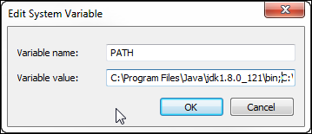

1. Click the **New** button to create another System Variable.
2. In the New System Variable window, enter the Variable name **CLASSPATH**, enter the Variable value **C:\Program Fles\Java\jdk1.8.0_121\lib\tools.jar;.;** (this has a semicolon, a period, and a semicolon at the end), and then click the **OK** button.

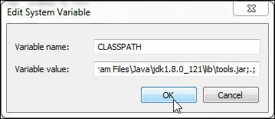.

1. You have created/updated three system variables. Click the **OK** button to close the Environment Variables and System Properties windows. Close the Control Panel window.

Windows 10 – Setting Environment Variables

Setting Up JAVA_HOME, PATH, and CLASSPATH Environment Variables

**Note:** You must be logged on to your computer as the Admin user.

1. In Windows Desktop, right-click on **This PC** and select **Properties**. Click **Advanced system settings**.
2. Click **Environment Variables**.
3. In the Environment Variables window, under **System Variables**, click the **New** button.
4. In the New System Variable window, enter the Variable name **JAVA_HOME**, enter the Variable value **C:\Program Files\Java\jdk1.8.0_121**  and then click the **OK** button.

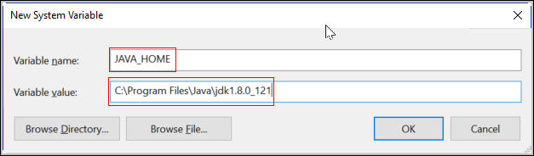

1. Select **PATH** system variable and click the **Edit** button (If PATH system variable is not available, click the **New** button to create PATH variable, enter the Variable value **C:\Program Files\Java\jdk1.8.0_121;** and then click the **OK** button).
2. In the Edit Environment Variable window, click **New** button and enter **C:\Program Files\Java\jdk1.8.0_121\bin** then click the **OK** button.

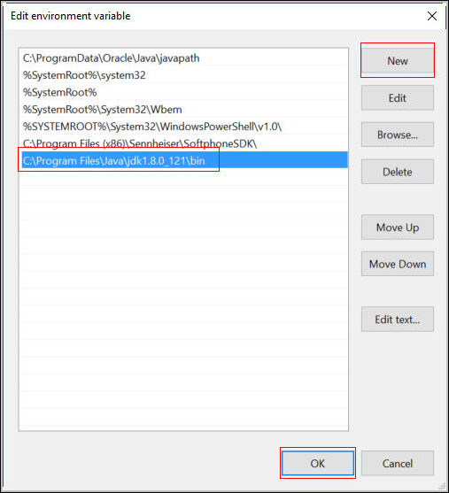

1. Click the **New** button to create another System Variable.
2. In the New System Variable window, enter the Variable name **CLASSPATH**, enter the Variable value **C:\Program Fles\Java\jdk1.8.0_121\lib\tools.jar;.;** (this has a semicolon, a period, and a semicolon at the end), and then click the **OK** button.

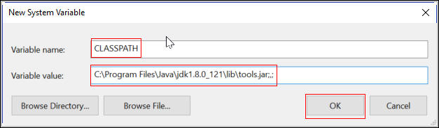.

1. You have created/updated three system variables. Click the **OK** button to close the Environment Variables and System Properties windows.

Verifying the JDK Installation

1. **Verify the Java version:** Open a Command Prompt window and run the java -version command. This verifies that a JRE is installed but does not verify that the JDK is installed. Verify that the output of the java –version command shows “1.8.0_121” or higher.

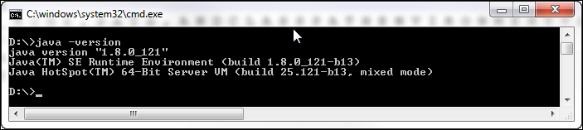

Installing Netbeans

Use the following instructions to download, install, and configure Netbeans IDE on your computer.

**Note: Netbeans 8.1** is the latest version available at the time of creating this document. It is highly recommended that you download the newer version of the IDE (if available) and perform these lab activities.

If you already have the Netbeans 8.1 or higher version installed on your computer then skip **Installing Netbeans** step and proceed with **Verifying the Netbeans Installation** step.

1. In the Firefox browser, navigate to <https://netbeans.org/downloads/>.
2. Download Netbeans 8.1 version which supports **All** technologies from the last column.
3. Download the **netbeans-8.1-windows.exe** installer file on to your computer. The download may take some time. Wait for the download to complete before proceeding to the next step.
4. Double-click the **netbeans-8.1-windows.exe** file to start the installation.

**Note:** If you receive a security warning such as “Do you want to allow the following program to make changes to this computer?” click **Yes**.

1. When the installer opens, click the **Customize**… button, click the check box to select **Apache Tomcat 8.0.27** under the **Runtimes** section, and click the **OK** button.
2. Click the **Next** button on the Welcome screen to proceed with the installation.
3. Accept the terms in the license agreement and click the **Next** button.
4. Accept the default **Install the NetBeans IDE to:** path for NetBeans, make sure the correct installation path of JDK (jdk1.8.0_121) is selected in the **JDK for the NetBeans IDE:** field, and click the **Next** button.
5. Accept the default installation path for **Glassfish** and **Apache Tomcat** and click the **Next** button**.** Clickthe **Install** button on the Summary window.
6. Wait until the installer installs the Netbeans and displays a “**Setup Complete**” message. Click the **Finish** button.

Verifying the Netbeans Installation

1. **Verify Netbeans:** To start the Netbeans IDE and verify the version number of the JDK used by the IDE, double-click the **Netbeans 8.1** shortcut on the desktop. Netbeans opens to a “Start Page.” Open the **Help** menu and select **About**. The Netbeans and Java versions should be **Netbeans IDE 8.1** and **Java 1.8.0_121.** When done, **Close** the **About** window.

Installing GIT

Use the following instructions to download, install, and configure GIT Tool on your computer.

**Note: GIT 2.11.0.3** is the latest version of the tool available at the time of creating this document. It is highly recommended that you download the newer version of this tool   
(if available) and perform these lab activities.

If you already have the GIT 2.11.0.3 or higher version installed on your computer then skip **Installing GIT** step and proceed with **Verifying the GIT Installation** step.

1. In the Firefox browser, navigate to <https://git-scm.com/downloads> and click the **Downloads for Windows** button.
2. Download the **Git-2.11.0.3-64-bit.exe** installer file to your computer. The download may take some time. Wait for the download to complete before proceeding to the next step.
3. Double-click the **Git-2.11.0.3-64-bit.exe** file to start the installation.

**Note:** If you receive a security warning such as “Do you want to allow the following program to make changes to this computer?” click **Yes**.

1. When the installer opens, click the **Next** button.
2. Accept the default installation path for **GIT** and click the **Next** button.
3. Accept the default selection on the **Select Components** screen and click the **Next** button.
4. Accept the default value on the **Select Start Menu Folder** screen and click the **Next** button.
5. Select the **Use Git from Git Bash only** option on the **Adjusting your PATH environment** screen and click the **Next** button.

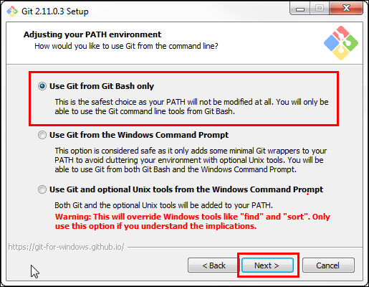

1. Accept the default selection on the **Configuring the line ending conversions** screen and click the **Next** button.
2. Accept the default selection on the **Configuring the terminal emulator to use with Git Bash** screen and click the **Next** button.
3. Accept the default selection on the **Configuring extra options** screen and click the **Next** button.
4. Accept the default selection on the **Configuring experimental options** screen and click the **Install** button. Wait until the installer installs the **Git 2.11.0.3** and displays a “**Setup has finished installing Git on your computer**” message. Click the **Finish** button.

Verifying the GIT Installation

1. **Verify GIT:** Open **Git Bash** from the Windows **Start** menu and run the git --version command. Verify that the output of the git --version command shows “git version 2.11.0.windows.3.”

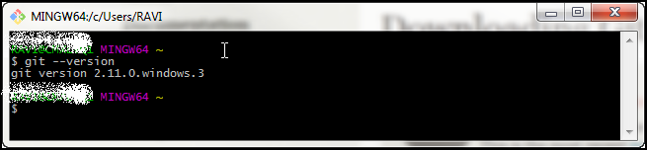

Installing Maven

Use the following instructions to download, install, and configure Maven on your computer.

**Note: Maven 3.3.9** is the latest version of the tool available at the time of creating this document. It is highly recommended that you download the newer version of this tool   
(if available) and perform these lab activities.

If you already have the Maven 3.3.9 or higher version installed on your computer then skip **Installing Maven** step and proceed with **Setting Up the M2_HOME, M2, and PATH Environment Variables** step to setup/verify the required environment variables.

1. In the Firefox browser, navigate to <http://maven.apache.org/download.cgi>.
2. Download the Binary ZIP archive, **apache-maven-3.3.9-bin.zip** file on to your computer. The download may take some time. Wait for the download to complete before proceeding to the next step.

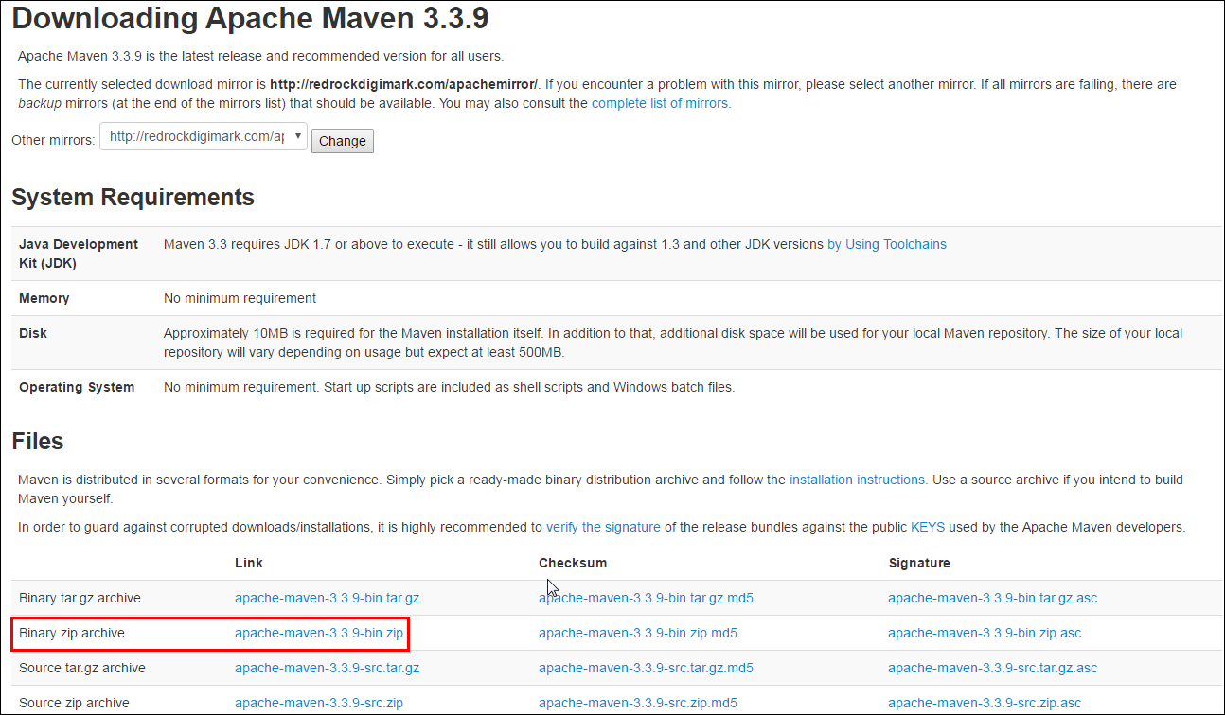

1. Create a directory named **Maven** in C:\ and unzip the distribution archive to **C:\Maven** directory.

**Note:** You should achieve the directory structure highlighted in the screenshot

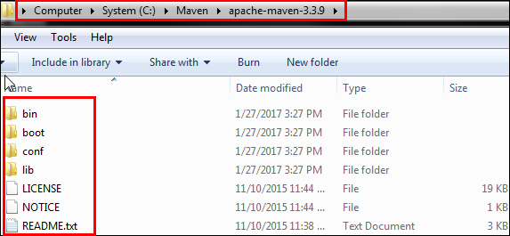

1. Copy the complete path (**C:\Maven\apache-maven-3.3.9**) once the extraction is completed; this is required to create environment variables.

Windows 7 – Setting Environment Variables

Setting Up the M2_HOME, M2, and PATH Environment Variables

**Note:** You must be logged on to your computer as the Admin user.

1. Click the Windows **Start** button. Right-click **Computer** and select **Properties**. Click **Advanced system settings**.
2. Click **Environment Variables**.
3. In the Environment Variables window, under **System Variables**, click the **New** button.
4. In the New System Variable window, enter the Variable name **M2_HOME**, enter the Variable value **C:\Maven\apache-maven-3.3.9** , and then click the **OK** button.

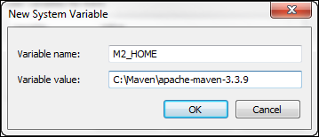

1. In the Environment Variables window, under **System Variables**, click the **New** button.

In the New System Variable window, enter the Variable name **M2**, enter the Variable value **%M2_HOME%\bin** , and then click the **OK** button.

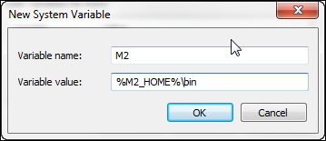

1. Select the **PATH** system variable and click the **Edit** button.
2. In the Edit System Variable window, in the Variable value field, place the cursor at the last position and enter **;%M2%,** and then click the **OK** button.

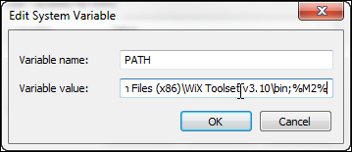

1. Click **OK** button twice to to close Edit System Variable and System Property windows

Windows 10 – Setting Environment Variables

Setting Up the M2_HOME, M2, and PATH Environment Variables

**Note:** You must be logged on to your computer as the Admin user.

1. In Windows Desktop, right-click **This PC** and select **Properties**. Click **Advanced system settings**.
2. Click **Environment Variables**.
3. In the Environment Variables window, under **System Variables**, click the **New** button.
4. In the New System Variable window, enter the Variable name **M2_HOME**, enter the Variable value **C:\Maven\apache-maven-3.3.9**  and then click the **OK** button.

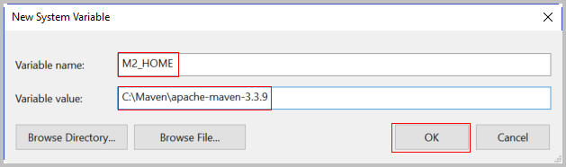

1. In the Environment Variables window, under **System Variables**, click the **New** button.

In the New System Variable window, enter the Variable name **M2**, enter the Variable value **%M2_HOME%\bin** , and then click the **OK** button.

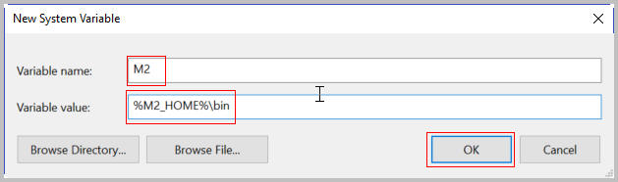

1. Select the **PATH** system variable and click the **Edit** button.
2. In the Edit System Variable window, in the Variable value field, place the cursor at the last position and enter **;%M2%,** and then click the **OK** button.

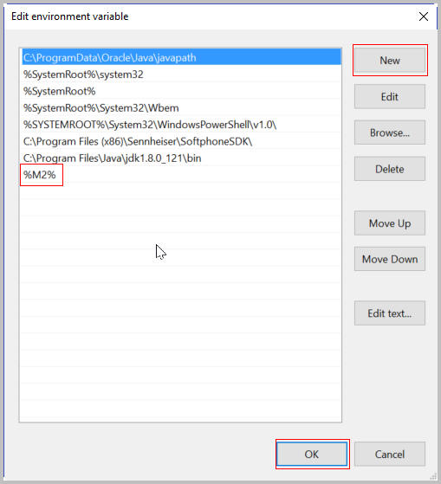

1. Click **OK** button twice to to close Edit System Variable and System Property windows

Verifying the Maven Installation

1. **Verify the Maven version:** Open a Command Prompt window and run the mvn --version command. Verify that the output of the mvn -–version command matches with the following screenshot:

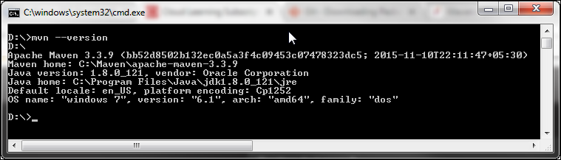

Proxy Settings for Maven in Netbeans

Oracle Internal & Oracle Academy Use Only

**Note:** Use the following instructions to change your proxy settings for Maven if you are part of the secured network and behind a firewall **ONLY.**

1. Open the C:\Program Files\NetBeans 8.1\java\maven\conf\settings.xml file with a text editor like Notepad++.
2. Add the following lines under the <proxies> tag:

<proxy>

<id>Oracle</id>

<active>true</active>

<protocol>http</protocol>

<host>**ENTER YOUR PROXY ADDRESS**</host>

<port>80</port>

<nonProxyHosts>localhost|oracle.com</nonProxyHosts>

</proxy>

1. Replace **ENTER YOUR PROXY ADDRESS** within the <host> tag with your proxy and save the file.

Oracle Internal & Oracle Academy Use Only

**Note:** If you are facing problems in editing the settings.xml file, save a copy of the settings.xml file to some other location, modify it, and then put it back in to C:\Program Files\NetBeans 8.1\java\maven\conf\ directory.

Creating a GIT Repository

1. Open Git Bash from the Windows **Start** menu.
2. In your home directory, create a **cloud** directory.

mkdir cloud

1. Change the directory to **cloud** directory.

cd cloud

1. Create a Git repository type.

git init

1. The cloud directory is now a Git repository. Execute the ls –a command to confirm the same. The output of the ls –a command must match the output in the following screenshot:

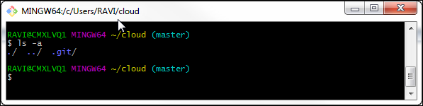

**Note:** Now you should see that a .git directory has been created inside the cloud directory and your repository is ready.

Configuring a GIT Repository

Before you commit changes to Git, you must configure your name and email address to identify your commits in the repository.

1. Execute the following commands to configure your name:

git config --global user.name “Your Name”

**Example:** git config –global user.name “John Doe”

1. Execute the following commands to configure your email address:

git config --global user.email your-email@address

**Example:** git config –global user.email [john.doe@oracle.com](mailto:john.doe@oracle.com)

1. To confirm that the values have been set, execute the following command:

git config --global –l

The output of these commands should match the output in the following screenshot:

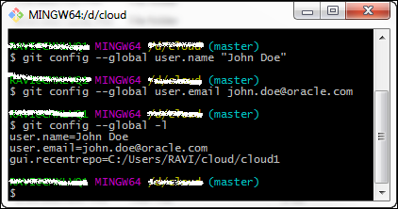

**Note:** This sets your name and email address for all Git projects on this system.

Proxy Settings for Maven

Oracle Internal & Oracle Academy Use Only

**Note:** Use the following instructions to change your proxy settings for Maven if you are part of the secured network and behind a firewall **ONLY.**

1. Open the C:\Maven\apache-maven-3.3.9\conf\settings.xml file with a text editor like Notepad++.
2. Add the following lines under the <proxies> tag:

<proxy>

<id>Oracle</id>

<active>true</active>

<protocol>http</protocol>

<host>**ENTER YOUR PROXY ADDRESS**</host>

<port>80</port>

<nonProxyHosts>localhost|oracle.com</nonProxyHosts>

</proxy>

1. Replace **ENTER YOUR PROXY ADDRESS** within the <host> tag with your proxy and save the file.

Oracle Internal & Oracle Academy Use Only

Creating a Project with Maven Archetypes

Use the following steps to create a Maven project using Archetypes from Git Bash or Command Prompt.

As part of this exercise, we are going to create a simple Maven project named, **Helloworld-Example** to print “Hello World!” message on the console. This project will be used in the following practices to store in a local GIT repository, create project on Developer Cloud Service and then Clone it to cloud GIT repository.

1. Open Git Bash from the Windows Start menu.
2. Change to the cloud directory where your Git repository is stored.

cd cloud

1. Create a directory named helloworld.

mkdir helloworld

1. Change to the Helloworld directory.

cd helloworld

1. Create an empty Maven project using the maven-archetype-quickstart archetype. Enter the following command:

mvn archetype:generate -DgroupId=com.example -DartifactId=Helloworld-Example -DarchetypeArtifactId=maven-archetype-quickstart -DinteractiveMode=false

**Note:** The output of this command must be similar to the output in the following screenshot:

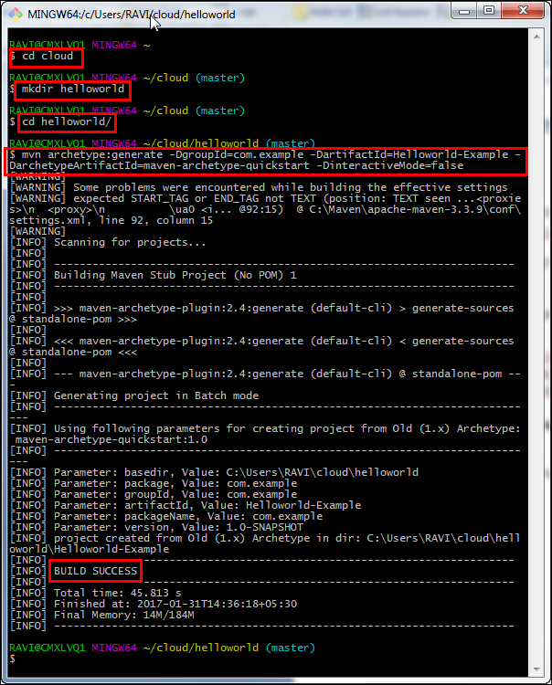

1. The command creates an empty Maven project named **Helloworld-Example**. Examine the directory structure and note that an executable class is located at com.example.App. Now the pom.xml file must be configured for   
   plug-ins.
2. Launch Netbeans using the shortcut on the desktop.
3. Open the **Helloworld-Example** Maven project created under **cloud/helloworld** directory in Netbeans.

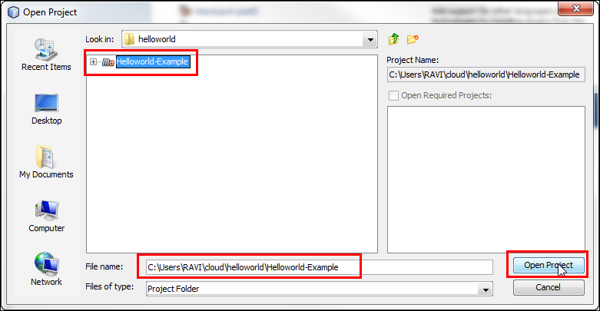

1. Examine the directory structure of the project, open **com.example.App** executable class, and review the code.

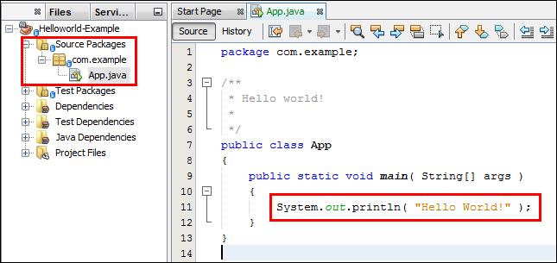

1. Right-click the **Project Files > pom.xml** file and click Open.

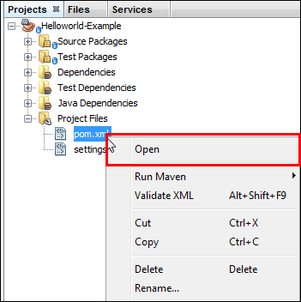

1. Add the following properties settings to the file before the dependencies section. This sets the Java version and encoding for the project.

<properties>

<java.version>1.8</java.version>

<project.build.sourceEncoding>UTF-8</project.build.sourceEncoding>

</properties>

1. After the dependencies element, add elements for build and plug-ins.

<build>

<plugins>

<!-- Your plugins go here -->

</plugins>

</build>

1. Add the configuration for the compiler plug-in to the plug-ins section.

<plugin>

<groupId>org.apache.maven.plugins</groupId>

<artifactId>maven-compiler-plugin</artifactId>

<version>2.3.2</version>

<configuration>

<source>1.8</source>

<target>1.8</target>

</configuration>

</plugin>

1. Add the exec plug-in to the pom.xml file.

<plugin>

<groupId>org.codehaus.mojo</groupId>

<artifactId>exec-maven-plugin</artifactId>

<version>1.4.0</version>

<executions>

<execution>

<goals>

<goal>exec</goal>

</goals>

</execution>

</executions>

<configuration>

<mainClass>com.example.App</mainClass>

</configuration>

</plugin>

1. Add the JAR plug-in to the pom.xml file.

<plugin>

<groupId>org.apache.maven.plugins</groupId>

<artifactId>maven-jar-plugin</artifactId>

<version>2.6</version>

<configuration>

<archive>

<manifest>

<mainClass>com.example.App</mainClass>

</manifest>

</archive>

</configuration>

</plugin>

1. In the source window, right-click the **pom.xml** file and select **Format** to fix the indentation for the file.

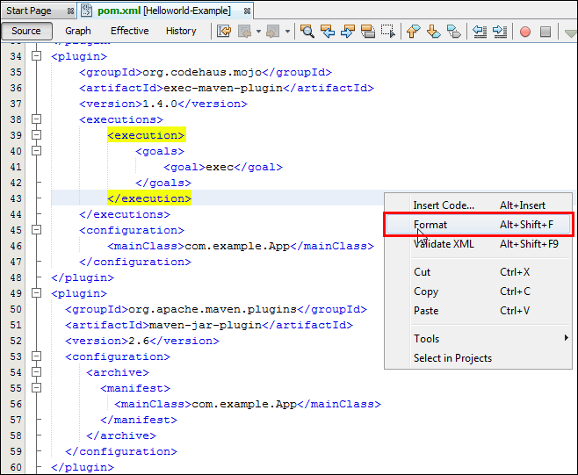

1. Save the **pom.xml** file.
2. Right-click the **Helloworld-Example** projectand click **Run.**

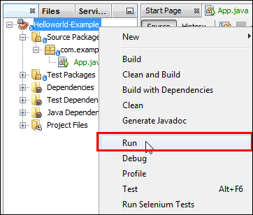

1. Select **com.example.App** from the Available Main Classes list and click the **Select Main Class** button.

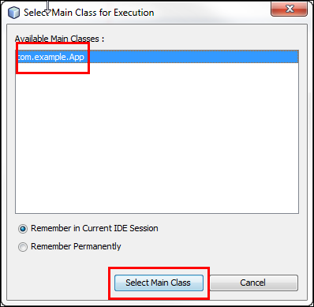

1. You should see **Hello World!** Output with a BUILD SUCCESS message.

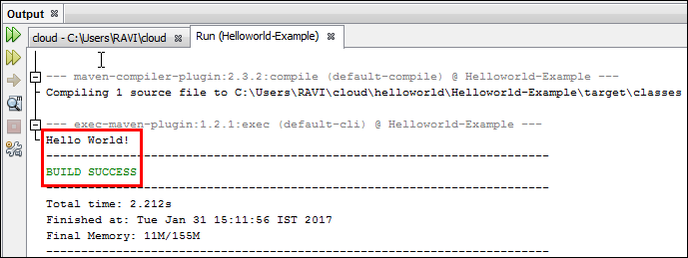

1. Switch to **Git Bash** and change the directory to Helloworld-Example.

cd Helloworld-Example

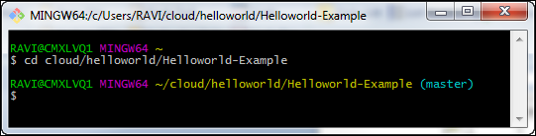

1. Execute the mvn clean compile command to clean and compile the project.

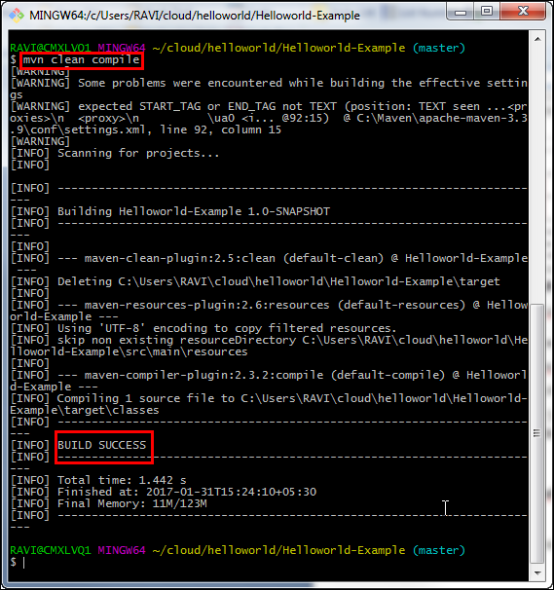

1. Execute the mvn exec:java command to execute the application.

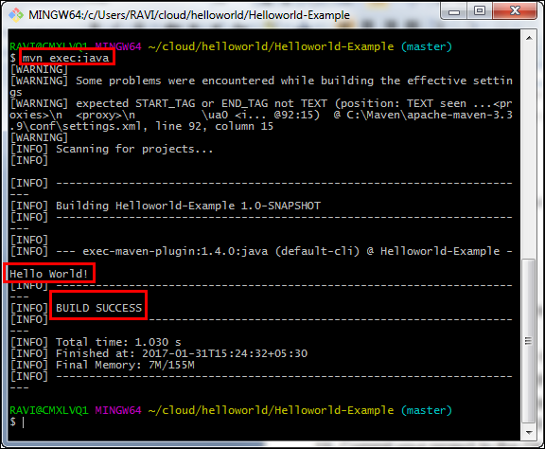

1. Execute the mvn package command to package the application.

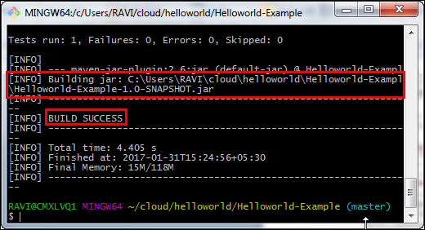

**Note:** Examine the **Helloworld-Example-1.0-SNAPSHOT.jar** file created inside **cloud/helloworld/Helloworld-Example/target** directory.

1. Execute the java -jar target/Helloworld-Example-1.0-SNAPSHOT.jar command to run the packaged application.

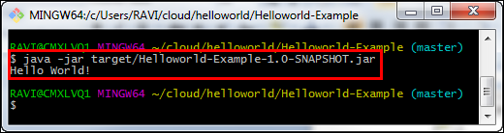

Checking the Helloworld-Example Project into a GIT Repository

Execute the following commands to commit the Helloworld-Example project to a GIT repository.

1. Change into the cloud/helloworld directory.
2. Execute the git add –n . command to see the list of files that are ready to be added to the repository.

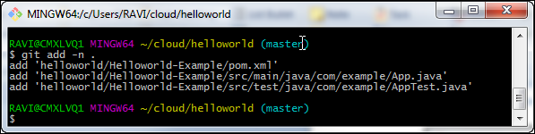

**Note:** Please notice that there is **.** at the end of the command.

1. Execute the git add . command to add the files to the repository.

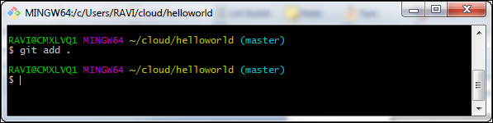

1. Execute the git status command to check the files that are added.

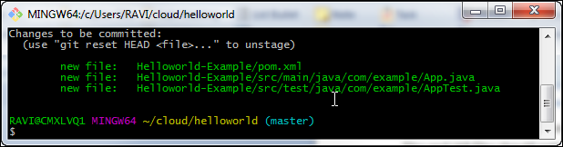

1. Execute the git commit –m “Initial Commit for Helloworld-Example Project” to commit the files to the repository and begin version tracking.

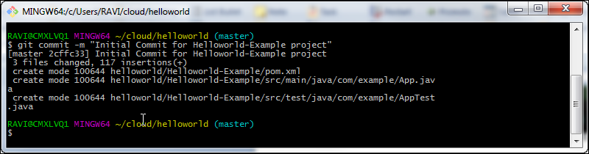

1. Your files are now checked in for version tracking.
2. Check the status of the repository by executing the git status command.

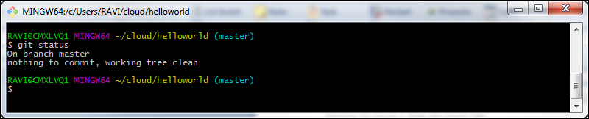

**Note:** You should get a response similar to the one in the screenshot.

Creating a Developer Cloud Service Project

Activating Developer Cloud Service

**Note:** The cloud login credentials and link are required to perform this part of the exercise. Gather this information from the email you have received from Oracle and keep it handy.

1. In a Firefox browser, navigate to <https://cloud.oracle.com/home>.
2. Click the **Sign In** button.

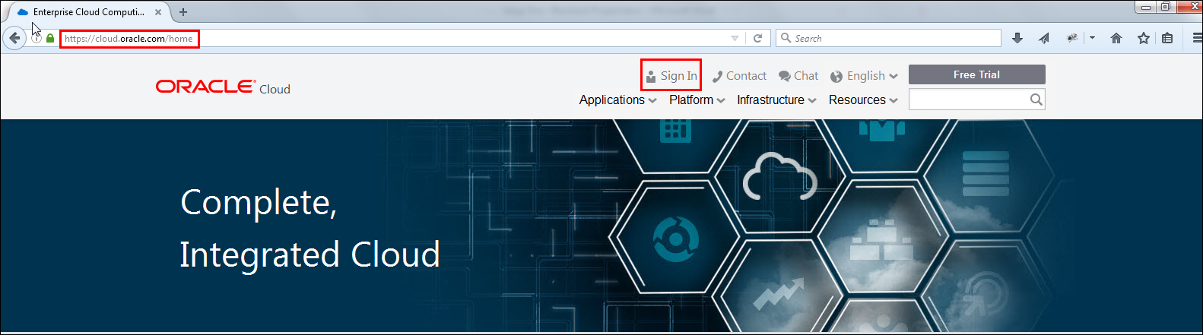

1. Select the Data Center and click the **My Services** button (the Data Center name is available in the email sent by Oracle).

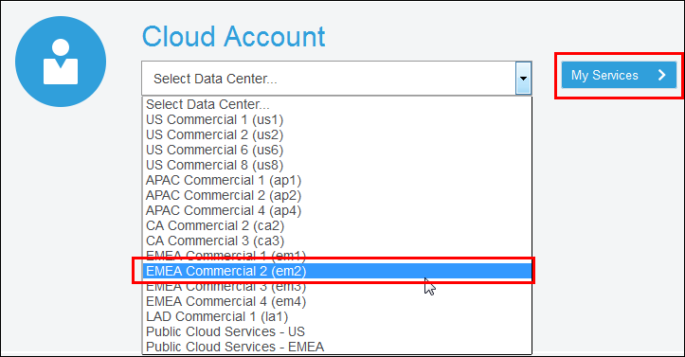

1. Enter the Identity Domain name and click the **Go** button (the Identity Domain name is available in the email sent by Oracle).

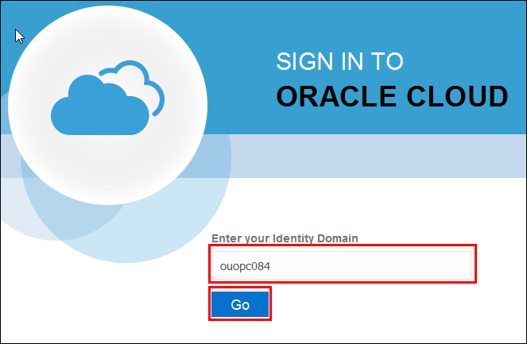

1. In the next screen, enter the username and the password and click the **Sign In** button (login credentials are available in the email sent by Oracle).

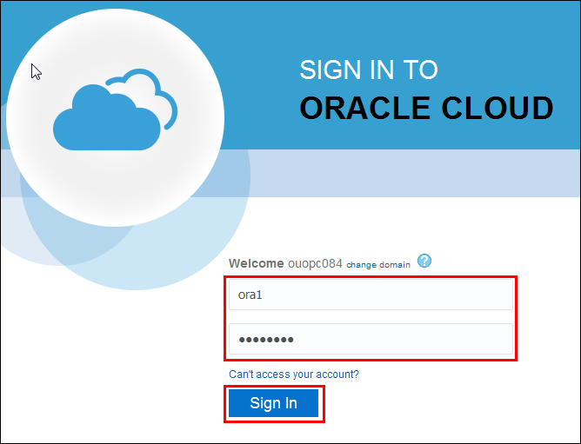

1. On successfully logging in, we can see the **Identity Domain Name** and the **Username** on the Welcome page.

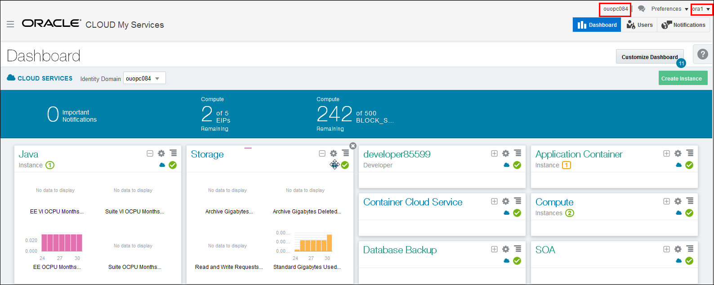

1. Services that are assigned to your account will be visible on the Dashboard. If the **Developer** service is not visible, click the **Customize Dashboard** button and the **Show** button for **Application Container** to make it visible on the Dashboard.

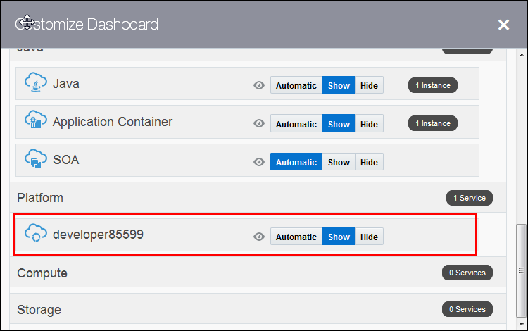

1. Click **Developer Cloud Service** on the Dashboard to go to the **ServiceDetails:developer85599 (Oracle Developer Cloud Service)** page.

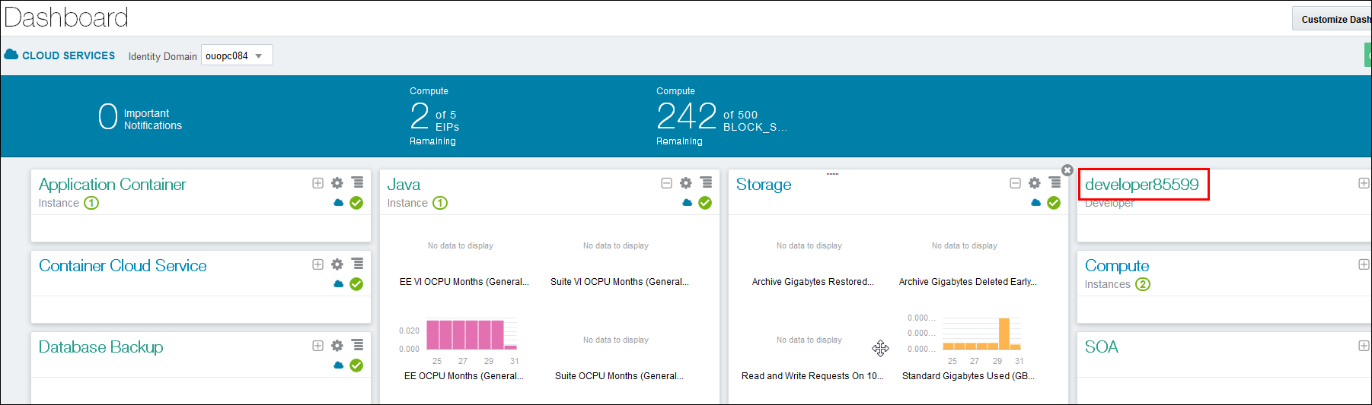

1. Click the **Open Service Console** button.

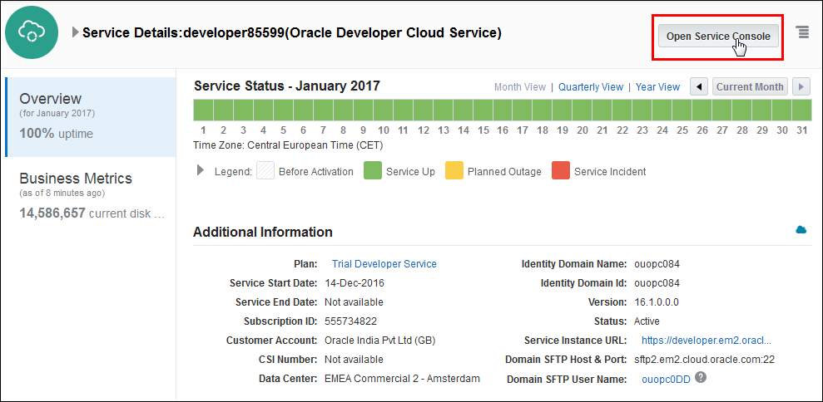

1. Click **New Project.**

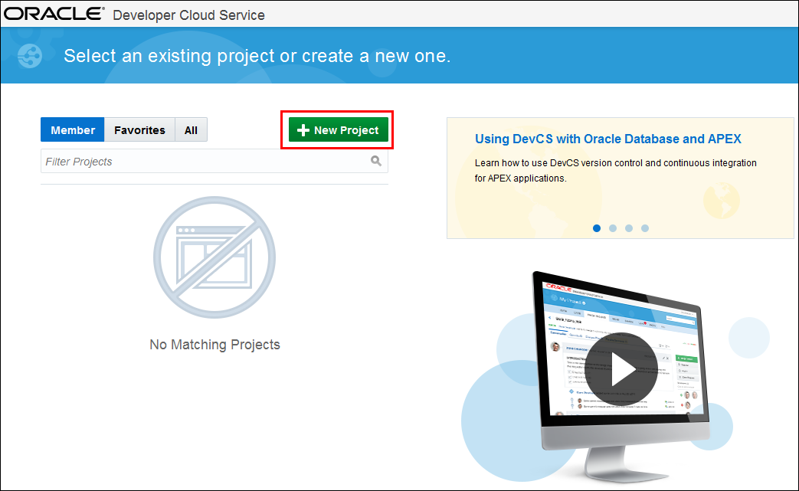

1. Enter the Project Name and Description as shown in the following screenshot and click **Next.**

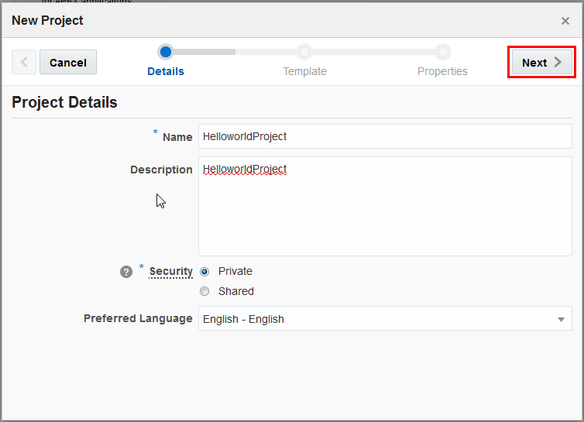

1. Click the **Empty Project** template and **Next.**

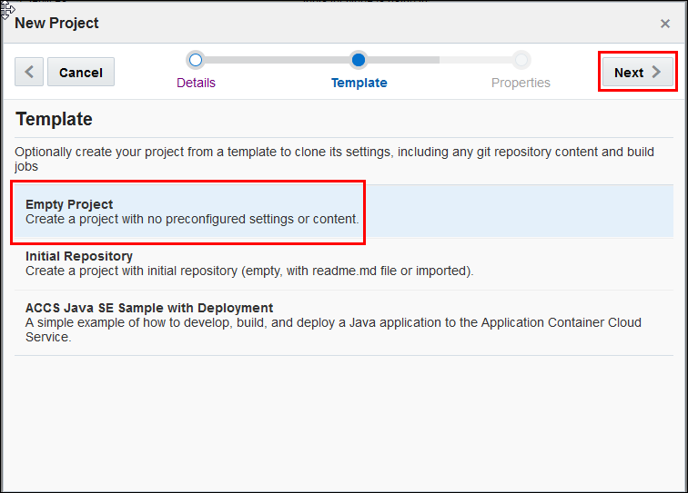

1. Select **MARKDOWN** from the Wiki Markup drop-down list and click **Finish.**

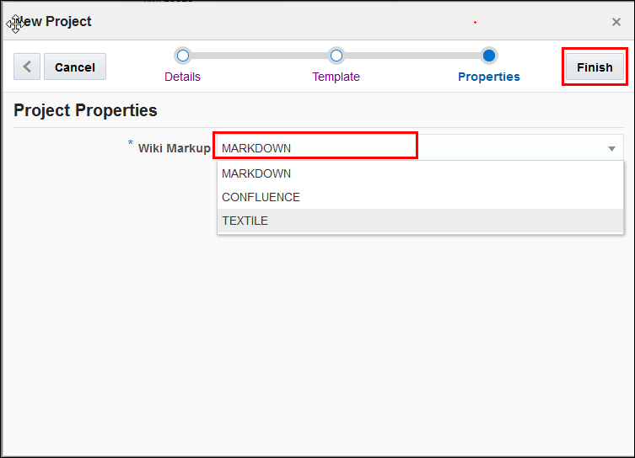

1. Provisioning HelloworldProject may take several minutes. Wait until all the modules are provisioned and redirected to the HelloworldProject home screen.

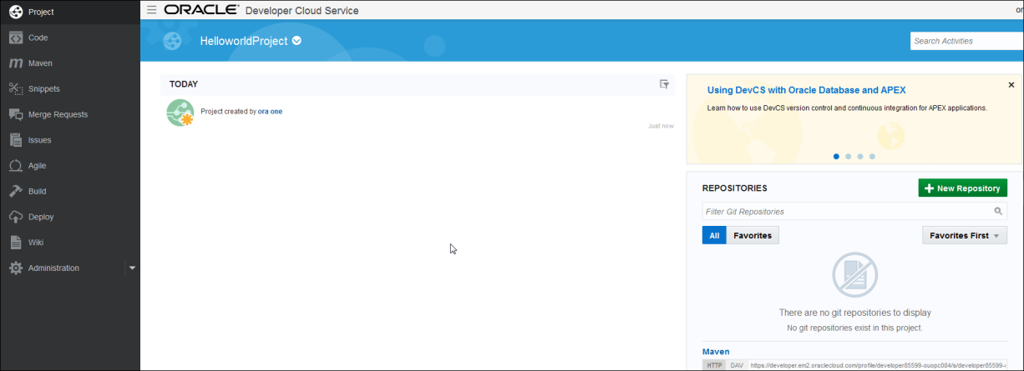

Creating a GIT Repository in Developer Cloud Service

Use the following instructions to create an empty GIT repository on Developer Cloud Service.

1. Click the **New Repository** button in the **REPOSITORIES** section.

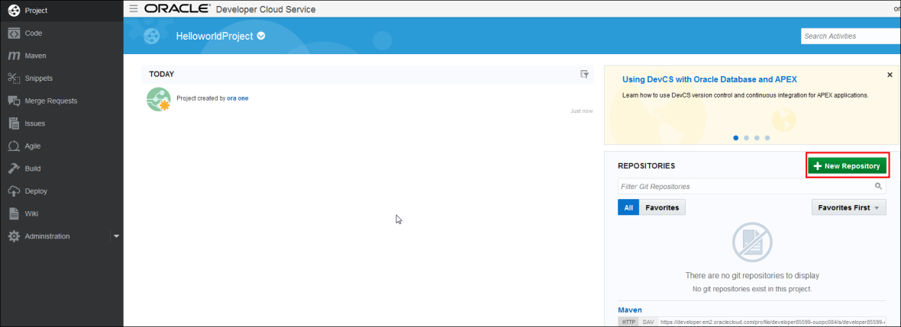

1. In the New Repository window, enter the repository name and description as shown in the following screenshot and click **Create.**

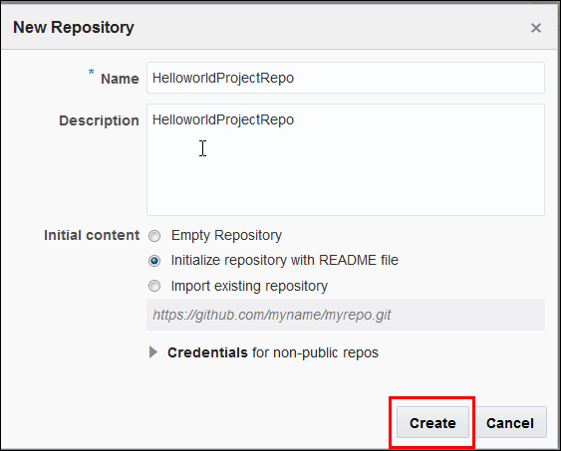

1. It may take a few minutes to create a repository. Wait until the HelloworldProjectRepo repository is created and redirected to the HelloworldProjectRepo home page.

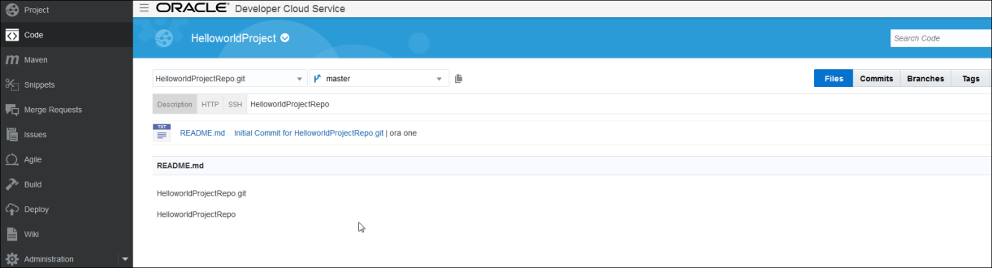

1. Click the HTTP tab in the HelloworldProjectRepo home page and copy the URL.

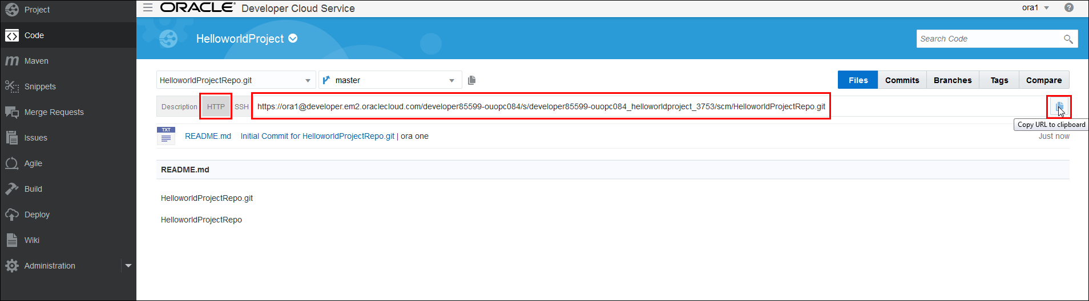

Cloning a GIT Repository

Use the following instructions to clone the Helloworld-Example project to a GIT repository on Developer Cloud Service.

1. To clone a GIT repository, first change to the cloud/helloworld directory that is the root directory for your repository.
2. Execute git clone <https://ora1@developer.em2.oraclecloud.com/developer85599-ouopc084/s/developer85599-ouopc084_helloworldproject_3753/scm/HelloworldProjectRepo.git>

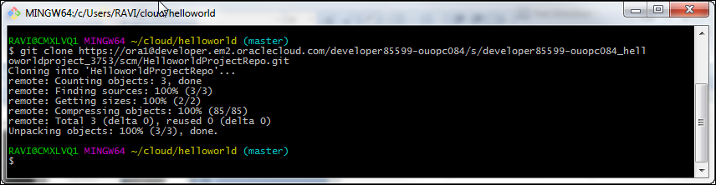

**Notes:**

* Enter your cloud account username and password, if you are prompted.
* Theoutput of this command should be similar to the output in the screenshot.

1. Notice that there is a new directory named **HelloworldProjectRepo** created inside **cloud/helloworld** directory.
2. Copy and paste **Helloworld-Example** projectdirectory from **cloud/helloworld** directory to **HelloworldProjectRepo** directory

**Note:** Content of the **HelloworldProjectRepo** directory should match with the contents listed below screenshot.

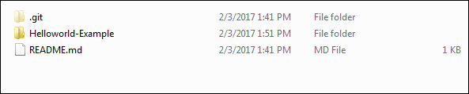

1. Change to the **HelloworldProjectRepo** directory

cd HelloworldProjectRepo

1. Add the source files to GIT from project root directory

git add .

1. Commit the changes

git commit –m “commiting changes to **HelloworldProjectRepo repository”**

1. Push the files to the repository on Developer Cloud Service

git push origin master

1. Switch to Developer Cloud Service to verify the files pushed to the repository
2. In the **HelloworldProject** home page, click on **HelloworldProjectRepo.git**

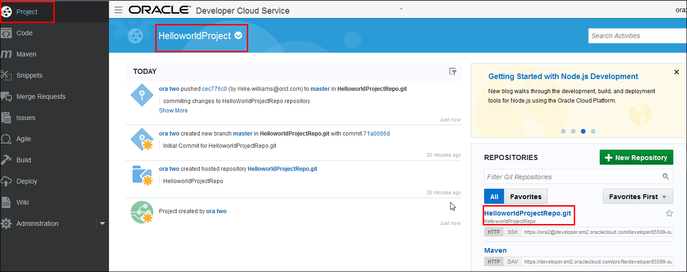

1. Notice that **Helloworld-Example** project directory has been pushed to repository on Developer Cloud Service. Click on it and verify its contents.

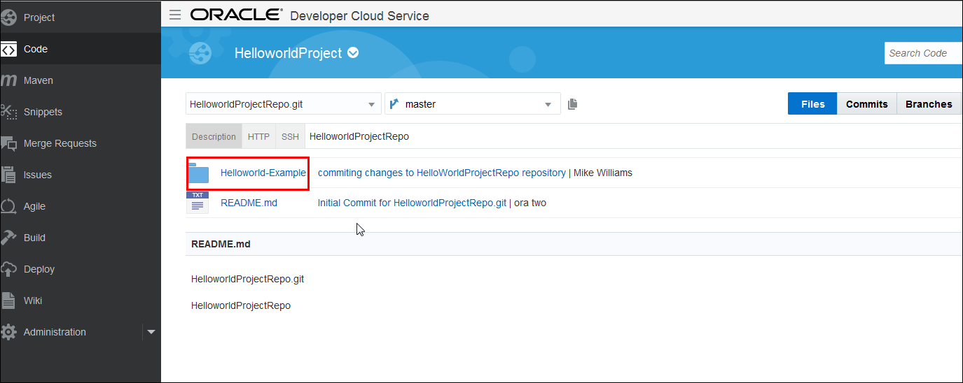

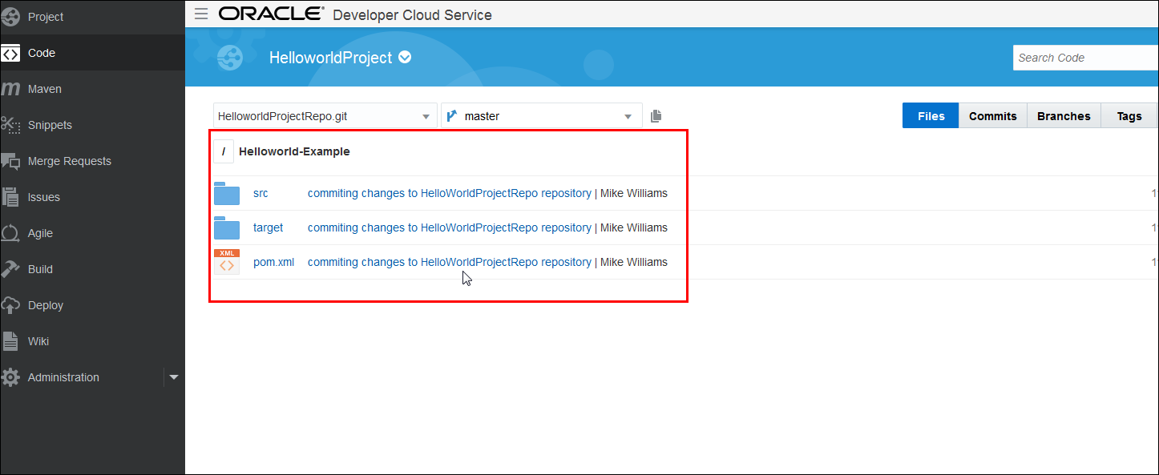

Downloading BlackJack Project from the Repository

<< Instructions for downloading the BlackJack project will go here, Diana or Peter to provide the link>>

Deploying the BlackJack Application on a Local Server

Use the following instructions to deploy the BlackJack application to Apache Tomcat Server bundled with the project.

1. Open Windows Explorer and navigate to the **cloud** directory.
2. Inside the **cloud** directory, create a directory named **BlackJack** and copy the **BlackJack.zip** file that you downloaded in the previous exercise.
3. Unzip the **BlackJack.zip** file to the **cloud** **>** **BlackJack** directory.
4. Launch Netbeans using the shortcut on the desktop.
5. Open the **blackjack-part2** project in Netbeans.

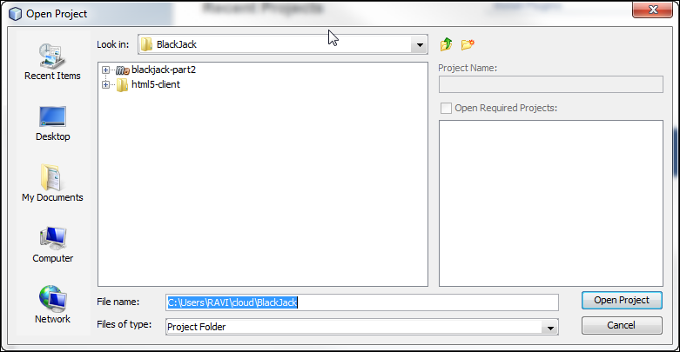

**Note:** If you see a [Unloaded] tag against the project name then right-click on the project and select, **Resolve Project Problems** and then click on Resolve button. Please wait until Netbeans downloads the Maven related files then click on close button.

1. Right-click the project and select the **Clean and** **Build** option.

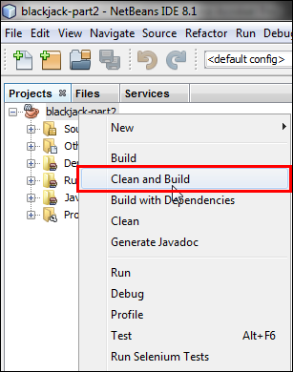

1. Right-click the project and select **Run** to deploy the project on Tomcat Server.

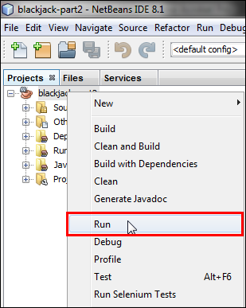

1. Select **com.example.blackjack.rest.Application** from the Available Main Classes list and click the **Select Main Class** button.

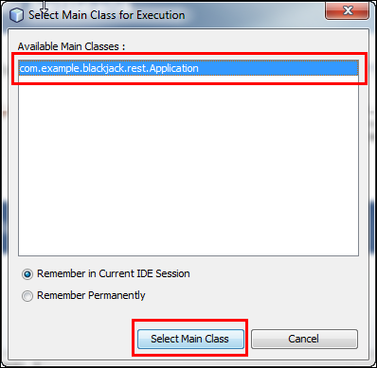

1. You should receive a “*Started Application in <<seconds>> seconds (JVM running for 5.19)*” message in the Output window.

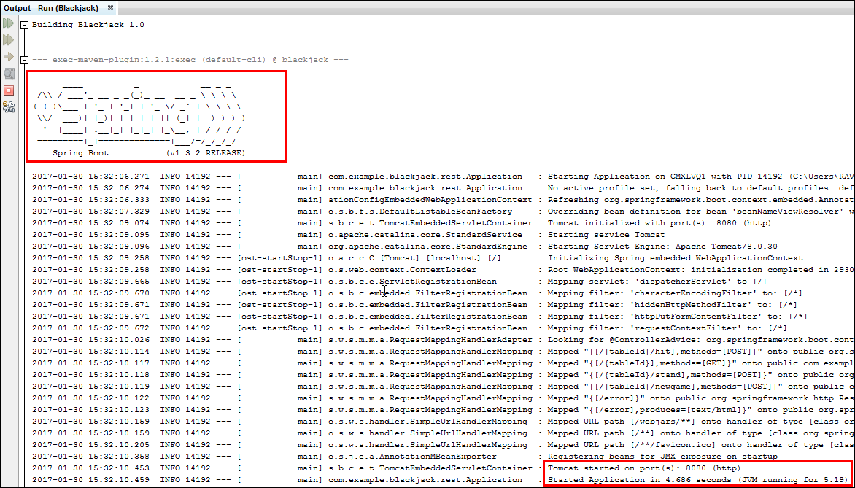

**Note:** You may encounter a problem in running this project due to a port conflict issue. This application will be deployed to Apache Tomcat Server and this server requires **8080** port number to listen to the client request. Make sure you stop the services using **8080** port number.

**TCPView** tool can be used to identify and terminate the process using this port number.

[**Download Link**](https://technet.microsoft.com/en-us/sysinternals/bb897437)

Testing the Locally Deployed BlackJack Application

An HTML-5 client application has been developed and supplied with the BlackJack application to test its functionality once deployed on a local/remote server.

Use the following instructions to test the BlackJack application.

1. Open Windows Explorer and navigate to the **cloud > BlackJack > html5-client** directory.
2. Open the index.html file with a browser.
3. Make sure that the first field, **Service,** is populated with [**http://127.0.0.1:8080/**](http://127.0.0.1:8080/)value, enter a number between 1 and 9 in the second field, and then click Connect.

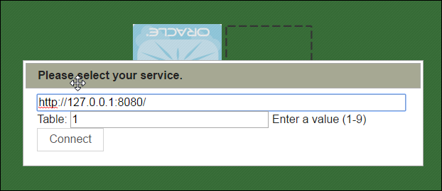

1. Once you connect to the gaming console, click the **Debug on/off** button to view the Debug console.

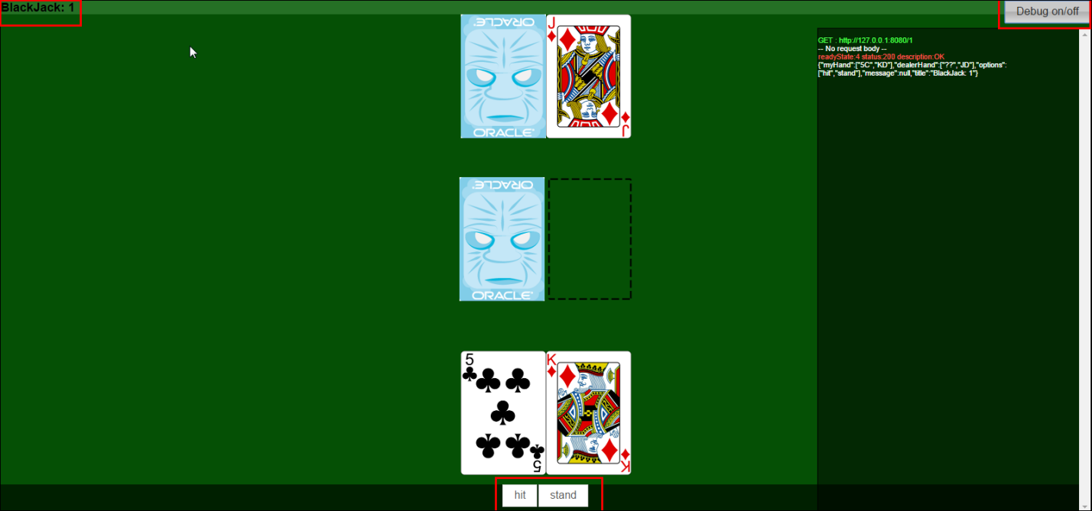

You can use the **Hit** and **Stand** buttons available on the UI to play the game.

This HTML5 Client application interacts with the BlackJack gaming application deployed on Tomcat Server running locally on your computer. Close this HTML5 Client application once you are done.

Generating Application Archive Files for the BlackJack Application

Oracle Application Container Cloud can deploy and run Java Platform, Standard Edition (Java SE), and Node.js applications. First, to deploy our application, we compress the application in a **ZIP** or **Gzipped Tar (TGZ)** archive file, which includes the required configuration information. Then, we use the Oracle Application Container Cloud graphical user interface (GUI) to deploy our application. With the application deployed, we can test and run our application and manage the application’s size.

Use the following steps to deploy the application to OACCS(Oracle Application Container Cloud Service).

1. Open the blackjack-part2 application in Netbeans if it is not opened already.
2. Right-click the project and click **Clean.**

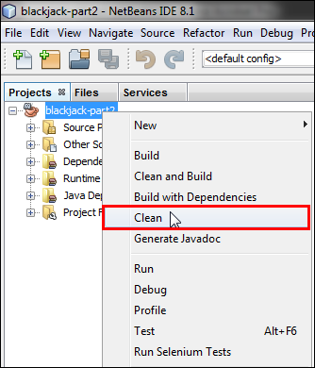

1. Open Windows Explorer, navigate to **cloud > BlackJack > blackjack-part2,** and make a note of the directory structure and its contents.

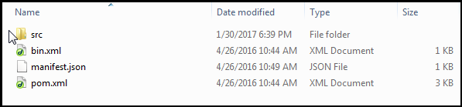

1. Switch to Netbeans, right-click the project, and click **Build.**

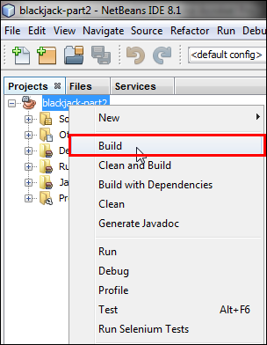

1. Switch to the **cloud > BlackJack > blackjack-part2** directory and notice that a new directory named **target** is created.
2. Examine the **target** directory. You will notice that **.zip and .tar.gz** distribution files have been generated. These are application archive files that we can use to deploy to OACCS.

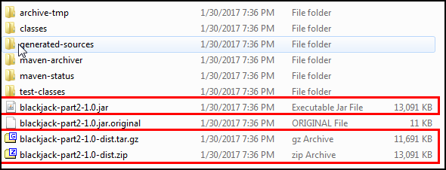

Activating Oracle Application Container Cloud Service (OACCS)

**Important Note:** The cloud login credentials and link are required to perform this part of the lab activity. Gather this information from the email you have received from Oracle and keep it handy.

For the purpose of creating this document, a cloud instance from the EMEA region Data Center was used. You will get a cloud instance from the NAMER region Data Center; select the Data Center accordingly.

1. Sign In to Oracle Cloud account (Refer to **Activating Developer Cloud Service** section for detailed instruction on how to Sign In)
2. On a successful Sign In, we can see the **Identity Domain Name** and the **Username** on the Welcome page.



1. Services that are assigned to your account will be visible on the Dashboard. If the **Application Container** service is not visible, click the **Customize Dashboard** button and **Show** button for **Application Container** to make it visible on the Dashboard.

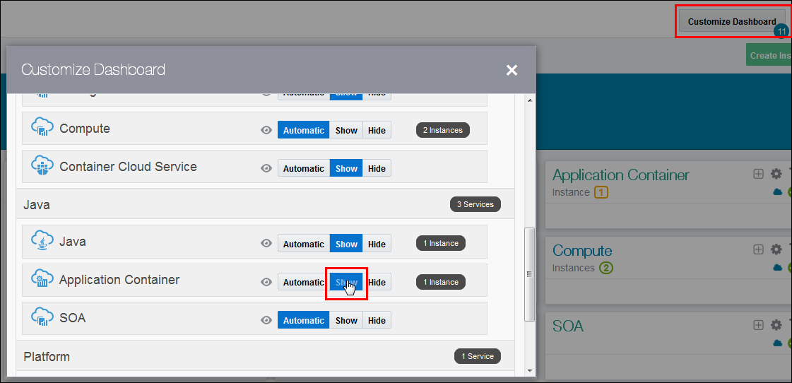

1. Click the **Application Container** on the Dashboard to go to the **Service Details: Oracle Application Container Cloud** page.

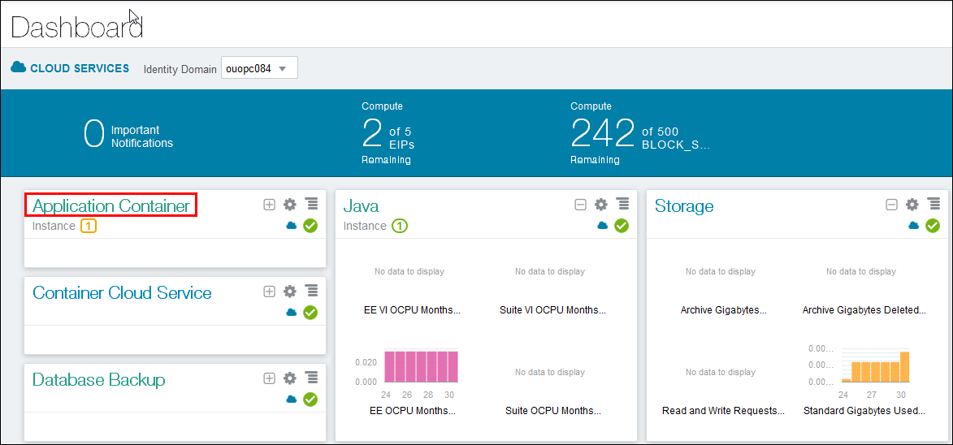

Deploying the BlackJack Application on OACCS

Use the following instructions to deploy the BlackJack application archive that you generated for OACCS as part of the previous exercise.

1. Click the **Open Service Console** button.

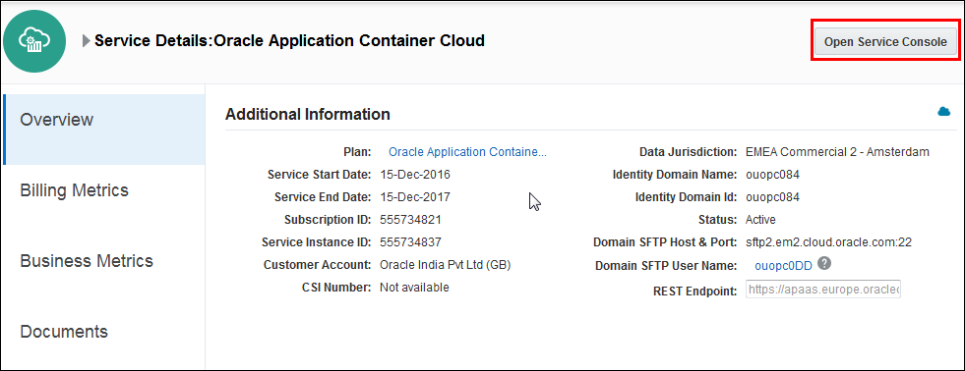

1. Click the **Create Application** and **Java SE** buttons**.**

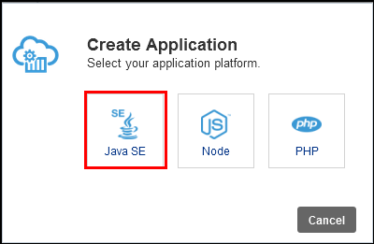

1. In the **Create Application** dialog box, enter BlackJack-part2 for the application name, select **Monthly** for the subscription type, and enter **Deploying BlackJack Application** in the Notes field. For the Application Archive field, select **Upload Archive**.

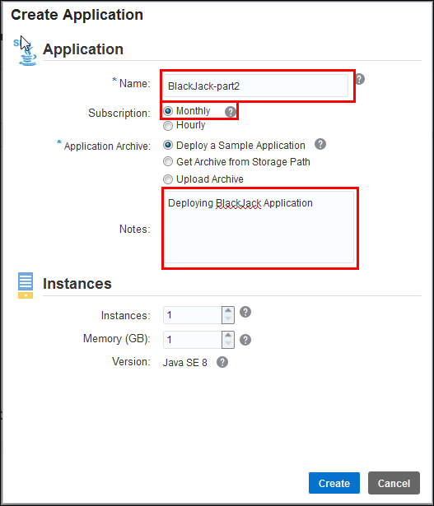

1. Browse and select the **blackjack-part2-1.0-dist.zip** file from the **target** directory.

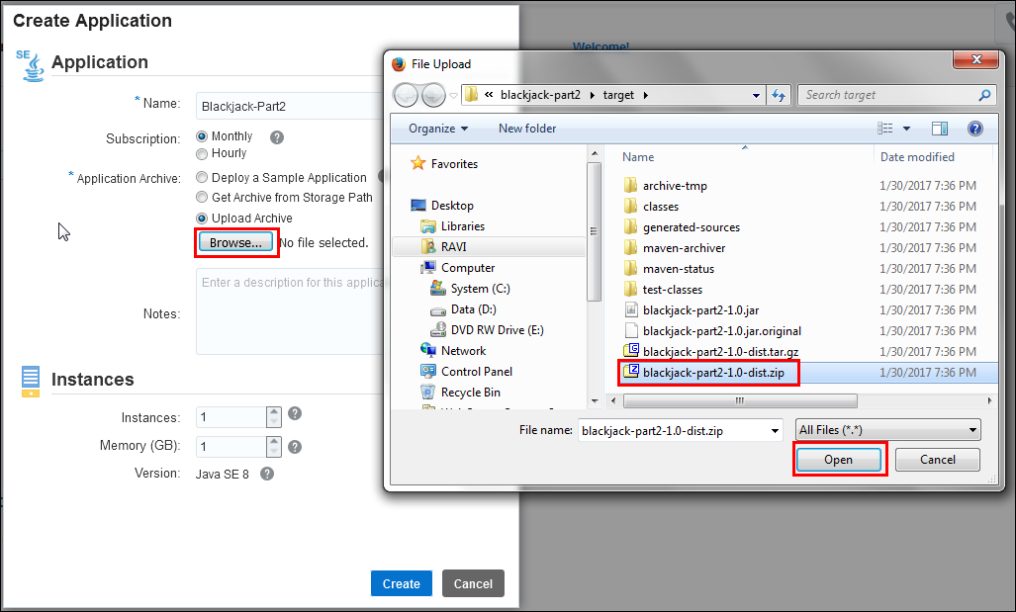

1. The **Create Application** dialog box now shows the selected file. Under **Instance**, review the number of instances and the memory size, and make any necessary adjustments. Click **Create** to deploy your application to Oracle Application Container Cloud.

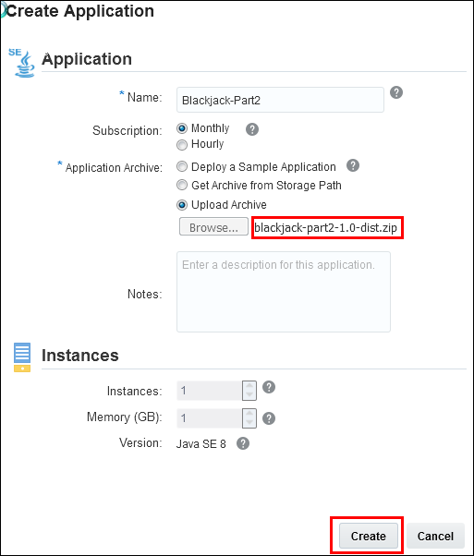

1. A status message appears indicating that it is **Processing Archive.**

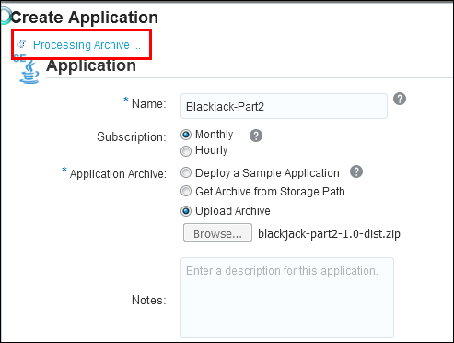

1. After the archived application is uploaded, the service determines whether the archive is properly configured. If it is, the following dialog box appears. Click **OK**.

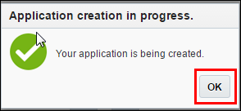

1. It will take several minutes to deploy the application. The deployment status can be viewed under the In-Progress Activity section.

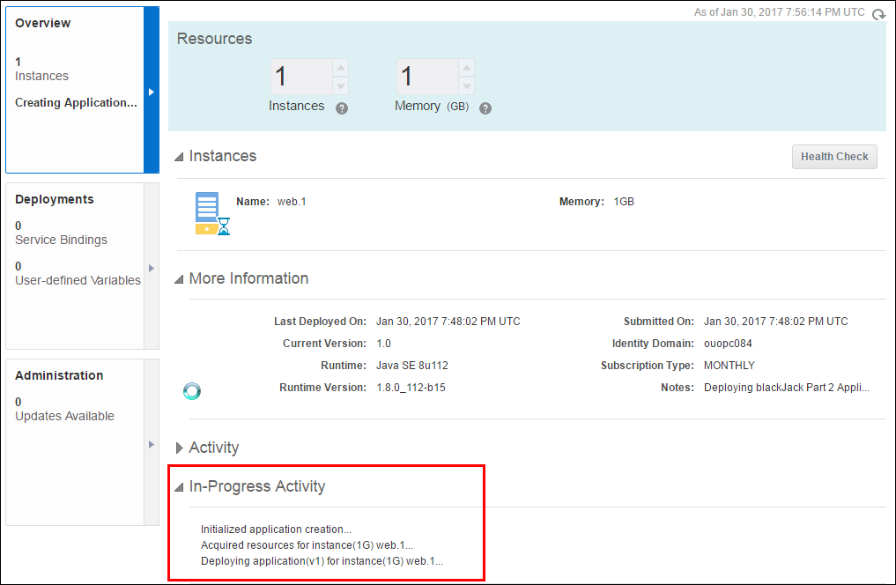

1. You should see a **Status: Succeeded** message in the Activity section once the application has been deployed successfully.

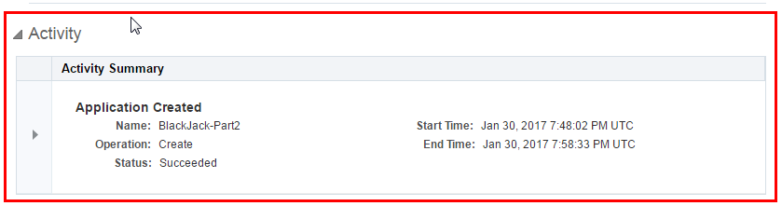

1. Copy the application URL and paste it in a notepad. We will need this URL for testing purposes.

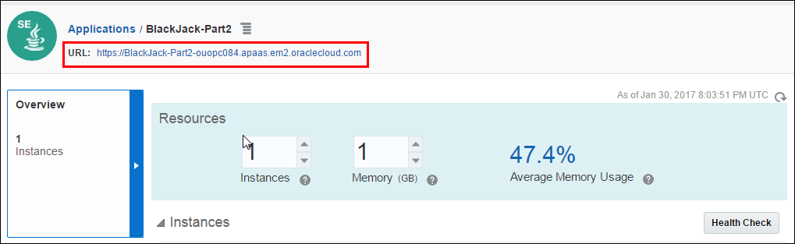

Testing the BlackJack Application Deployed on OACCS

An HTML-5 client application has been developed and supplied with the BlackJack application to test its functionality once deployed on a local/remote server.

Use the following instructions to test the BlackJack application.

1. Open Windows Explorer and navigate to the **cloud > BlackJack > html5-client** directory.
2. Open the index.html file with a browser.
3. Make sure that the first field, **Service,** is populated with the URL you copied in the previous exercise and add a /(forward slash) at the end, [**https://blackjack-part2-ouopc084.apaas.em2.oraclecloud.com/**](https://blackjack-part2-ouopc084.apaas.em2.oraclecloud.com/) . Enter a number between 1 and 9 in second field, and then click Connect.

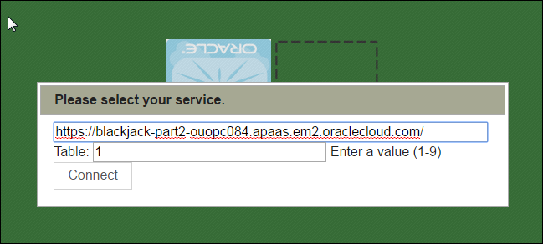

1. Once you connect to the gaming console, click the **Debug on/off** button to view the Debug console.

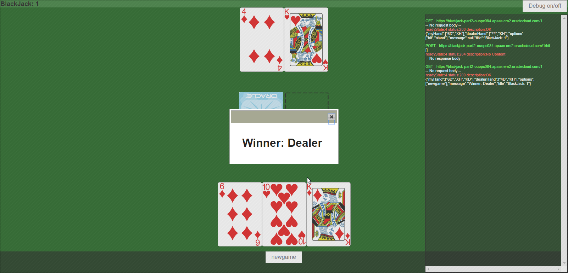

**Note:** You can use the **Hit** and **Stand** buttons available on the UI to play the game.

This HTML5 Client application interacts with the BlackJack gaming application deployed on OACCS on cloud.